September 7, 2022
Dear Parents and Guardians,
Many families, perhaps even you, have shared the challenges of getting your child to school in the morning. This has often resulted in students being late and missing mornings at school. Over time, this can impact on a child’s learning and, as the gap grows, children can lose interest in learning.
For the remainder of this year, Maple Leaf will be offering a Walking School Bus. The Walking School Bus is NOT a bus ride. It is an adult who will walk with a group of children to school every morning.
How does this work?
- All interested parents/guardians must sign the permission slip below
- All children MUST be READY to go at the specified times to join the group as they pass each stop
- There will be NO KNOCKING on doors or waiting past these times
- The walking school bus facilitator (a school staff member) will walk the children to school wearing a bright yellow and orange patrol vest for high visibility

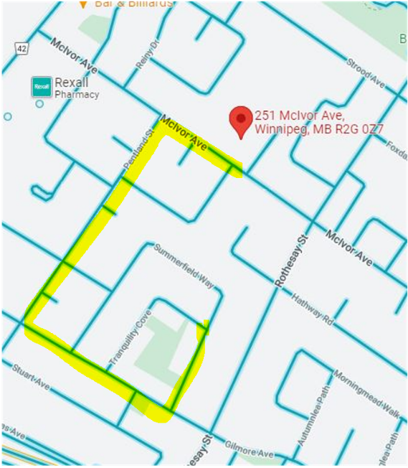
The Walking School Bus Schedule and Route
- The facilitator leaves from Tranquility Park (on Summerfield Way at 8:50 a.m.
- The facilitator and students walk from Summerfield Way to Gilmore Ave. They will continue along Gilmore Ave. to Pentland St. (reaching this intersection at 9:00 a.m.). Finally, crossing Pentland St. at McIvor Ave., continuing to Maple Leaf School on McIvor Ave.
- A child can join the in on the walk anywhere along the route
- The Walking School Bus goes to school every school day, Monday to Friday
- The Walking School Bus will be cancelled when winter temperatures reach –34C, as RETSD patrol guidelines suggest not exceeding 10 minutes of exposure outside at this temperature. It is your responsibility to bring your child on these colder days.
If you are interested in having your child participate in the walking school bus, fill out the information below and send it back with your child. Only children who are registered for the Walking School Bus can participate. The Walking School Bus will begin on Monday, September 12th, 2022.
Sincerely,

Jamie Evans
Principal

Fill out this form and send it back with your child if you are interested in having them join the Walking School Bus.
Walking School Bus Permission Slip

I would like my child _________________________________ in grade ______ and room ______ to be included in the Walking School Bus every day.

I am interested in VOLUNTEERING to walk with the facilitator and the children:
___________ Everyday
___________ Circle best days for you to help MON TUES WED THURS FRI

I will ensure that my child is ready at the scheduled time for the Walking School Bus. I give my permission for my phone number to be given to the Walking School Bus facilitator in case of changes or cancellations.

I understand that my child must be respectful and follow the guidance of the Walking School Bus facilitator and/or other Walking School Bus supervisors, or they will no longer have the privilege of joining the group.

Parent/Guardian Name: ____________________________________ Date: _____________________

Parent/Guardian Signature: ____________________ Telephone Number: ________________________

