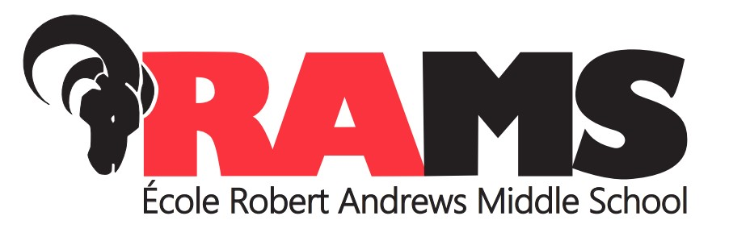

Dear Parents/Guardians:
Hockey Program on and off-ice Expectations
The Robert Andrews Hockey Program has grown and evolved over the past 10 years, adjusting to meet the needs of the students at Robert Andrews. To deliver the high quality of instruction that we plan to offer, it is important that students in the program understand that they must always conduct themselves appropriately.

Many people have worked extremely hard to institute this program and to ensure that we have access to the East St. Paul Arena. It is the responsibility of all students involved in the program to respect the equipment, facilities and people devoting their time to create a safe and successful learning environment.

Robert Andrews School expects the same behaviour at the rink, and to and from the rink, as we expect at school.

Students will be expected to arrive at the arena by 8:10 a.m. Practice starts at 8:30 a.m. sharp. Students are required to wait in the lobby area of the arena to be checked in by their teacher and are not permitted on the ice surface until the instructor is present. Practice ends at 9:20 a.m., and students need to be changed and ready to walk back to the school by 9:35. If equipment is being picked up at the rink, it must be done by 9:35 a.m., otherwise all equipment must be transported to the school safely and respectfully. Equipment may be stored in Room 10 at the school and should be removed by 6:00 p.m. In exceptional circumstances equipment may be left overnight. The school is not responsible for any lost or damaged equipment.

The following equipment is required (and should be labelled):
Helmet with full mask or cage Neck Guard (must be worn at all times)
Mouth Guard (must be worn at all times) Shoulder Pads
Elbow Pads Hockey Gloves
Hockey Pants Shin Pads
Skates Jock/Jill and Garter Belt
Hockey Socks Practice Jersey
A hockey bag to carry equipment Stick

Due to our stringent time schedule, all students must be able to get fully dressed and undressed in 15 minutes or less. The change room, the rink, and the walk to and from the rink are all extensions of the school and classrooms; respect for each other and the facility, and appropriate language are the expectation, the same as in school.

Students are encouraged, but not mandated, to bring shower items (including a bathing suit if necessary) to ensure proper hygiene is taken into consideration.

If there are any questions or concerns, please contact Mr. Chmelnytzki at mchmelnytzki@retsd.mb.ca.

Thank you for your assistance,

Mr. M. Chmelnytzki
Hockey Program Teacher

