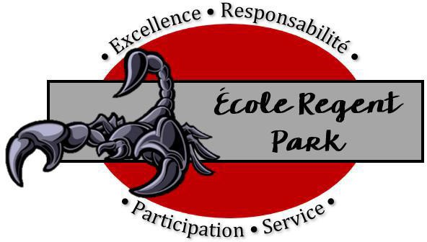
ÉCOLE REGENT PARK
Supply list for grade 5 students 2024-2025

- 1 soft pencil case with zipper
- 1- inch black binder and (5-pack dividers) for Music
- 2 boxes Kleenex
- 1 pair indoor runners
- Ear buds or headphones
- 1 water bottle
- $50.00 (cheque or cash): for classroom supplies such as pencils, erasers, scribblers, duo tangs, highlighters, pencil crayons, agenda etc.

STUDENT’S NAME SHOULD BE CLEARLY MARKED ON ALL INDIVIDUAL SUPPLIES.

Physical Education:

- Gym-appropriate footwear (indoor runners, weather-appropriate footwear for outdoors)
- Water bottle (optional

Students will not change for physical education. Students should wear appropriate clothing to school on gym days, including weather appropriate clothing (physical education may be indoors or outdoors).

Any extra supplies from previous years or from open packages may be sent to the office so that we can redistribute them as required to families in need in our school. Thanks!!

