SUPPLY LIST - 2025/2026
GRADE 1 - ENGLISH UKRAINIAN BILINGUAL PROGRAM
Pani Loughren – Room 1
$ 41.00 to be collected to cover the cost of duo tangs, pencils, erasers, glue, scissors, crayons, markers and art supplies. Supplies will be shared throughout the year.
$ 9.00 Student Agenda Book

$ 50.00 Total Student Fees

Student please bring:
- Pair of runners with Velcro fasteners and non-marking soles - to be left at school
- Large Backpack
- Ziploc bag with a complete change of clothes for your child
- Old T-Shirt for painting
- 3 boxes of tissues (200’s)
- 1 Set of earphones (that rest comfortably on your child’s head)
- 1 Roll of Parchment Paper
- 4” x 6” photo of child, with name printed in English (and Ukrainian if possible)
- Family photo 4” X 6” (with family members’ names)
- Lunch box (please provide nut-free morning and afternoon snacks, and lunch)
- Ukrainian shirt/blouse (to be kept at home)
PLEASE LABEL ALL SUPPLIES, CLOTHING, AND PERSONAL ITEMS WITH YOUR CHILD'S NAME

- Student fees are due by Friday, September 19, 2025
- Please make cheques payable to Prince Edward School
Traditional Ukrainian Shirt or Blouse:
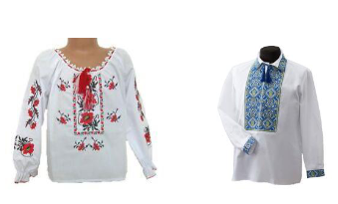
An important objective of our Ukrainian Heritage Language Program is to give students opportunities to participate in cultural events and activities. It is through this participation that students acquire an understanding and
appreciation of Ukrainian culture and tradition. Special cultural events, school assemblies, Ukrainian Easter Breakfast and choir performances are enhanced when students wear the traditional Ukrainian embroidered shirts and blouses. Please contact Pani Loughren if you require assistance with the purchase of a blouse or shirt.

